**DMIT 1508 - Lab 1: Stabff B Gone Solution**

**Youfang Yao (200582794)**

**Consignment Agreement View**

**Initial Table**

Consignment( **ConsignmentID(PK)**, Date, CustomerID, CustomerName, StaffID, StaffName, (ItemDesc, StartPrice, LowPrice, CategoryCode, CategoryDesc, CategoryCost), SubTotal, RewardsDiscount, GST, Total )

**1NF**

Consignment( **ConsignmentID(PK)**, Date, CustomerID, CustomerFirstName, CustomerLastName, StaffID, StaffFirstName, StaffLastName, SubTotal, RewardsDiscount, GST, Total)

ConsignmentDetail(**ItemID(PK)**, *ConsignmentID(FK),* ItemDesc, StartPrice, LowPrice, CategoryCode, CategoryDesc, CategoryCost)

**2NF**

Consignment( **ConsignmentID(PK)**, Date, CustomerID, CustomerFirstName, CustomerLastName, StaffID, StaffFirstName, StaffLastName, SubTotal, RewardsDiscount, GST, Total)

ConsignmentDetail(*ItemID(FK),* *ConsignmentID(FK)*)

ConsignmentItem(**ItemID(PK)**, ItemDesc, StartPrice, LowPrice, CategoryCode, CategoryDesc, CategoryCost)

**3NF**

Consignment( **ConsignmentID(PK)**,*CustomerID(FK)*, *StaffID(FK)*, Date, SubTotal, RewardsDiscount, GST, Total)

Customer(**CustomerID(PK)**, CustomerFirstName, CustomerLastName)

Staff(**StaffID(PK)**, StaffFirstName, StaffLastName)

ConsignmentDetail(*ItemID(FK), ConsignmentID(FK)*)

ConsignmentItem(**ItemID(PK)**, *CategoryCode(FK)*, ItemDesc, StartPrice, LowPrice)

CategoryItem(**CategoryCode(PK)**, CategoryDesc, CategoryCost)

**ERD**

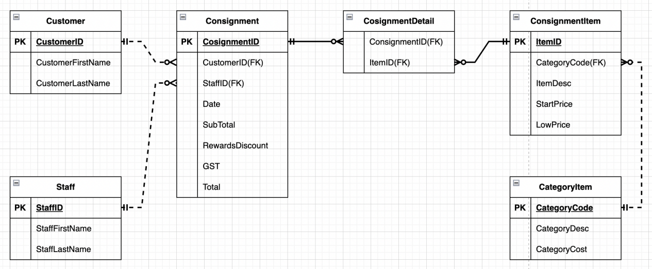

**Staff Training View**

**Initial Table**

Staff( **StaffID(PK)**, StaffName, TypeID, TypeName, (TrainingID, Description, StartDate, EndDate, PassAndFail))

**1NF**

Staff(**StaffID(PK)**, StaffFirstName, StaffLastName, TypeID, TypeName)

TrainingDetail(**TrainingID(PK)**, *StaffID(FK)*, Description, StartDate, EndDate, PassOrFail)

**2NF**

Staff(**StaffID(PK)**, StaffFirstName, StaffLastName, TypeID, TypeName)

TrainingDetail(*TrainingID(FK)*, *StaffID(FK)*, PassOrFail)

TrainingItem(**TrainingID(PK)**, Description, StartDate, EndDate)

**3NF**

Staff(**StaffID(PK)**, *TypeID(FK)*, StaffFirstName, StaffLastName)

StaffType(**TypeID(PK)**, TypeName)

TrainingDetail(*TrainingID(FK)*, *StaffID(FK)*, PassOrFail)

TrainingItem(**TrainingID(PK)**, Description, StartDate, EndDate)

**ERD**

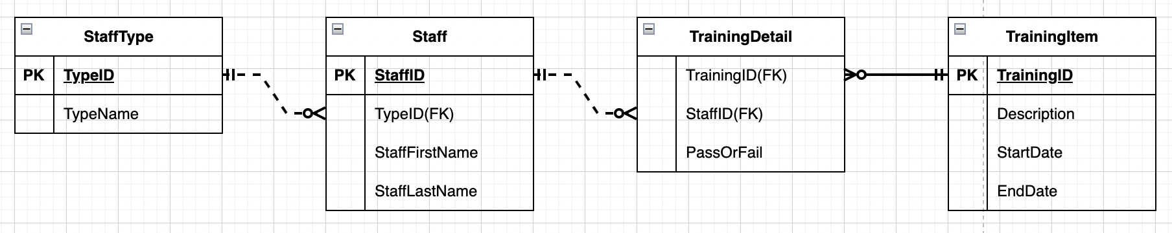

**Customer Rewards View**

**Initial Table**

Customer(**CustomerID(PK)**, CustomerName, Address, Email, Phone, RewardCode, RewardDescription, DiscountPercentage, CustomerTypeID, CustomerTypeDesc)

**1NF**

Customer(**CustomerID(PK)**, CustomerFirstName, CustomerLastName, StreetNo, City, Province, PostalCode, Email, Phone, RewardCode, RewardDescription, DiscountPercentage, CustomerTypeID, CustomerTypeDesc)

**2NF**

Customer(**CustomerID(PK)**, CustomerFirstName, CustomerLastName, StreetNo, City, Province, PostalCode, Email, Phone, RewardCode, RewardDescription, DiscountPercentage, CustomerTypeID, CustomerTypeDesc)

**3NF**

Customer(**CustomerID(PK)**, *CustomerTypeID(FK)*, *RewardCode(FK)*, CustomerFirstName, CustomerLastName, StreetNo, City, Province, PostalCode, Email, Phone)

RewardItem(**RewardCode(PK)**, RewardDescription, DiscountPercentage)

CustomerType(**CustomerTypeID(PK)**, CustomerTypeDesc)

**ERD**

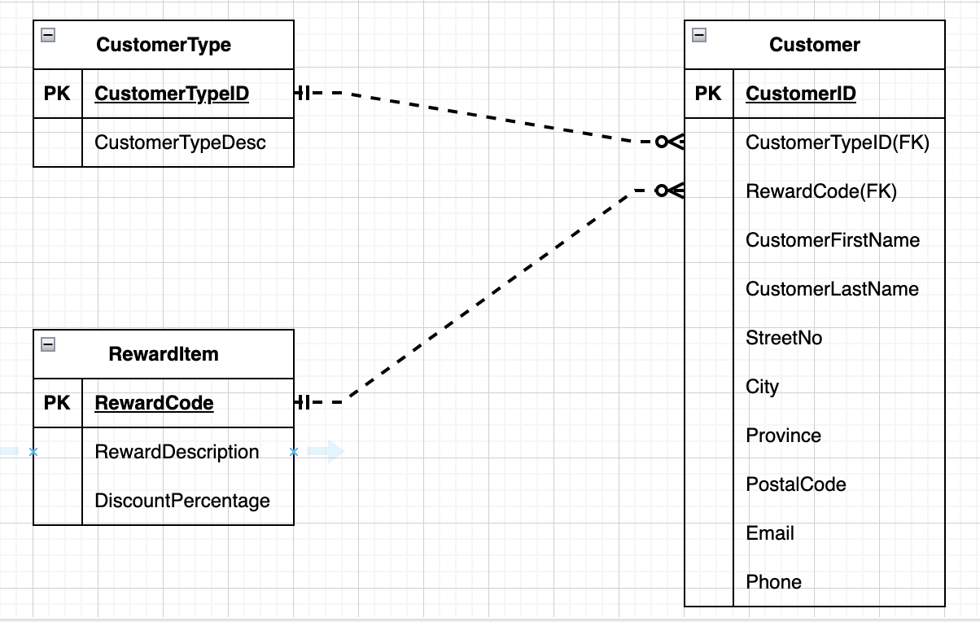

**Merged Tables**

Customer(**CustomerID(PK)**, *CustomerTypeID(FK)*, *RewardCode(FK)*, CustomerFirstName, CustomerLastName, StreetNo, City, Province, PostalCode, Email, Phone)

CustomerType(**CustomerTypeID(PK)**, CustomerTypeDesc)

RewardItem(**RewardCode(PK)**, RewardDescription, DiscountPercentage)

Staff(**StaffID(PK)**, *TypeID(FK)*, StaffFirstName, StaffLastName)

StaffType(**TypeID(PK)**, TypeName)

TrainingDetail(*TrainingID(FK)*, *StaffID(FK)*, PassOrFail)

TrainingItem(**TrainingID(PK)**, Description, StartDate, EndDate)

Consignment( **ConsignmentID(PK)**,*CustomerID(FK)*, *StaffID(FK)*, Date, SubTotal, RewardsDiscount, GST, Total)

ConsignmentDetail(*ItemID(FK)*, *ConsignmentID(FK)*)

ConsignmentItem(**ItemID(PK)**, *CategoryCode(FK)*, ItemDesc, StartPrice, LowPrice)

CategoryItem(**CategoryCode(PK)**, CategoryDesc, CategoryCost)

**Merged ERD**

